Where to Go for More Than Just Skiing

Of course, cruising down the pistes alongside our friends and family is the main reason we travel to the mountains on a skiing holiday. However, resorts have plenty more up their snowy sleeves than just the runs on the piste map.

We wanted to tell you about a selection of our favourite non-skiing activities so that you can really make the most of the experiences on offer in some of the best ski resorts in Europe. Whilst you’re sure to know some, chances are you won’t have tried them. From the extreme adrenaline rush to the serenely relaxing, all these amazing experiences in the snow will definitely take your next winter holiday to a level you didn’t think possible .

1. Tobogganing – Tignes
This is probably the only activity on the list you can practice at home when there is just a dabble of (terrible) UK snow. The idea is quite simple, just grab yourself a sled to sit on and point downhill.
Once the skills are honed there are plenty of places to show off your technique in the mountains. The 3 valleys are a great place to start with Courchevel, Les Menuires and Val Thorens providing the fun. Val Thorens boasts the longest toboggan run in Europe, with a descent of around 8 minutes .

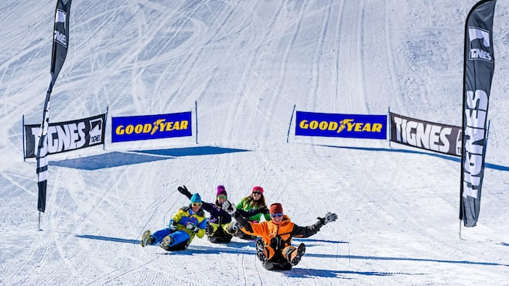

2. Airboarding – La Plagne
See the above but up the intensity! Have you ever fancied sliding head-first down a mountain? Well, then airboarding is/isn’t for you [delete as appropriate]. Airboarding is essentially bodyboarding for ski resorts; the airboard itself is an inflatable bodyboard. You slide down the mountain using your body weight to steer… which is made easier thanks to a grooved underside to the board. It is great for groups and families alike as you can all get involved at the same time .

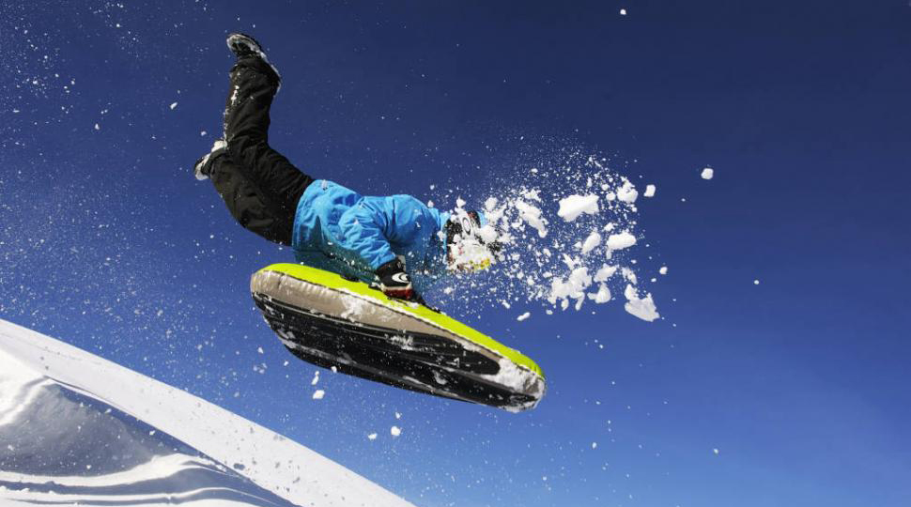

3. Snowshoeing – Chamonix
Let’s calm things down somewhat. We all know ski boots aren’t the most comfortable form of footwear out there, so what better excuse to swap them for a pair of snowshoes. These are the things that traditionally look like tennis rackets for your feet, and help you glide across the snow instead of sinking ever further down into the powder.

Chamonix, with its picturesque scenery and interesting wildlife, is the perfect location to take a day away from the noise of the resort and reconnect with nature .

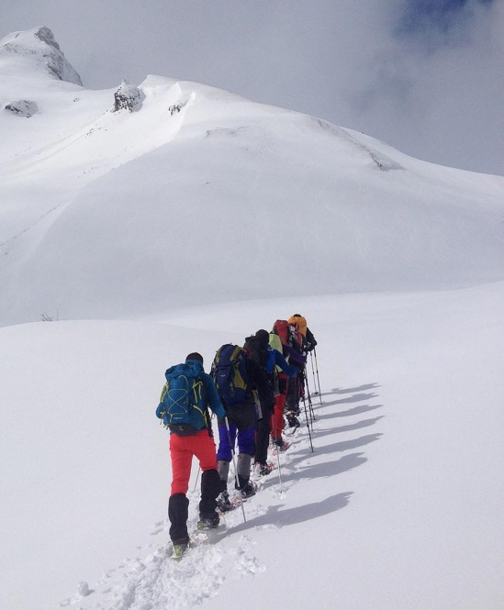

4. Ice Climbing – La Plagne, Tignes
Whether you fancy yourself as a bit of an explorer or whether you’re just a keen climber, ice climbing is a fantastic experience. Climb a frozen waterfall in full winter climbing gear adorned with harnesses, crampons and ice axes! This is available for various levels of climbers, from beginner to expert . All equipment provided, watch the experts in the video below. Do not worry though, a more leisurely pace is also acceptable.

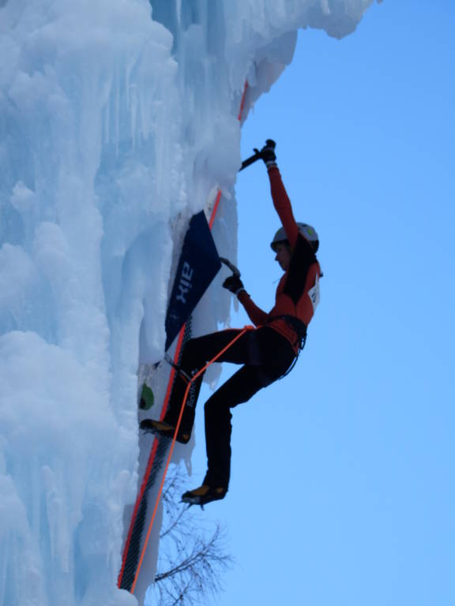

5. Snow Yoga – Val d’Isere and Val Thorens
Yoga with a view, these sessions take place on the side of the mountain and have an amazing alpine vista as your backdrop. It’s an enhanced experience for an activity that is, under usual circumstances, already great for the mind and body. For those who like their yin and yang aligned… avoiding high octane activities after a full day’s skiing may be the way forward. For survival purposes, the activity is carried out in your ski gear and there are classes to suit all abilities.

6. Skydiving – Courchevel
Sky diving is an incredible experience and there are some incredible places to do it, but as skiers we are slightly biased to a skydive over the mountains . After several thousand feet of free fall, and a heavy dose of adrenaline, get the best view of the mountains as you cruise back down to terra firma. All jumps are in tandem and come with training as well as equipment.

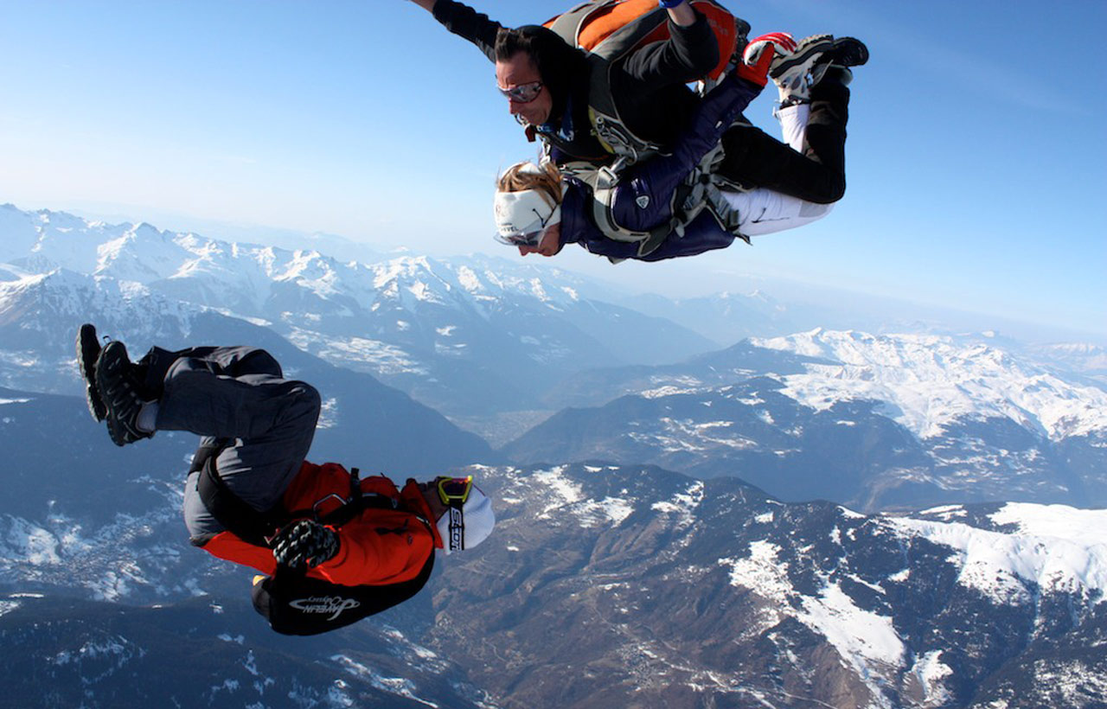

Continued…

7. Speed-Riding – Most Resorts (including Les Arcs, Chamonix)
Speed-riding is undoubtedly as exciting as it sounds and wouldn’t be out of place in Point Break. It combines paragliding with skiing, alternating between them as the speed-rider chooses. Whilst you need to be a decent skier, you don’t need any paragliding experience although our guys in resort said you do need to be very fit . It’s an amazing experience and one that can challenge your sporting abilities. Paragliding equipment is provided alongside tuition on gliding techniques, fundamental movements and flight mechanisms.

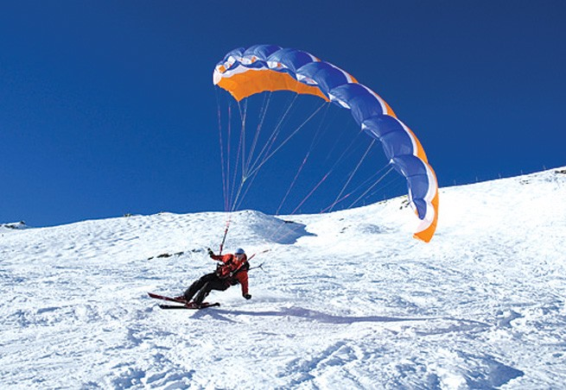

8. Ice Diving – Tignes and Val Thorens
Ever wanted to be on the other side of the camera in one of David Attenborough’s documentaries? Well now you can – ice diving allows you to explore the frozen world under the surface of the lake in Tignes. Dive into the eerie tranquillity, devoid of noise and movement, to appreciate the natural beauty of the ice formations and mercury-esque air bubbles . Full equipment is provided as well as professional advice and safety.

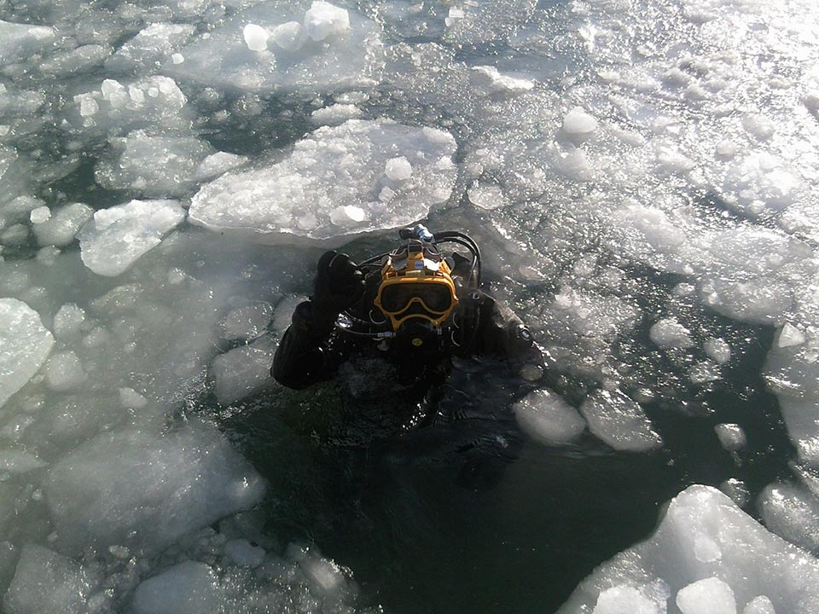

Continued…
9. Ski-Joering – Alpe d’Huez
Ski what?!? Ski-joering, it was brought to our attention by our overseas team and needs further explanation… Think horse-drawn cart racing but instead of the horse pulling a two-wheeled cart, it’s pulling you… on skis. You control the horse through a special rig with reigns. Aside from it being great fun; it is a great way to see the surrounding scenery. It’s suitable for non-riders and beginner skiers as training and instructions are provided on the day .

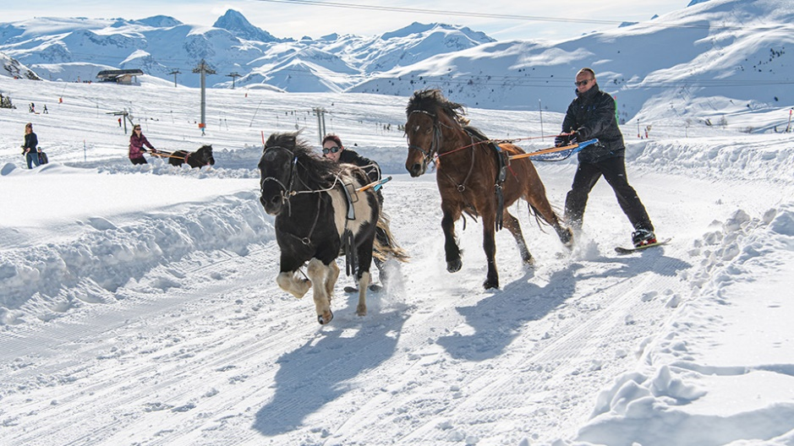

10. Helicopter Rides – Tignes and Val d’Isere
Have a taste of luxury on your ski holiday and see what the lifestyles of the rich and famous are like, even if only for a few minutes. Soar above the peaks to where the air is rarefied and see the best views around, mixing scenery with a little touch of adventure. It’s also more affordable than you would think.

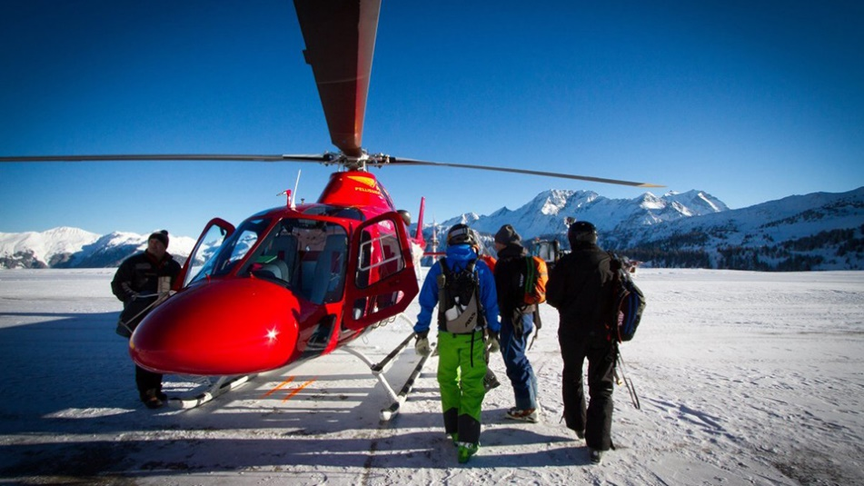

If you fancy a ski holiday with a little extra variety on the itinerary, get yourself booked into a few of these activities…You’re sure to create lasting memories and who knows, your ski holidays may never be the same again!

Find out more:
📞 0117 452 1159
📧 support@worldclassadventures.co.uk
🌐 worldclassadventures.com
#worldclassadventures #beadventurous

